**Employee Navigator integration setup Guide**

Contents

Things to know & Limitations 1

Integration Set Up 1

Frequently Asked Questions 4

**Getting Started**

Lattice and Employee Navigator have partnered to develop an integration that includes the synchronization of certain demographic and deduction data. This guide consists of an overview of the integrated fields, as well as steps to complete within Lattice Payroll for the setup of the integration. This guide should be reviewed in conjunction with the **Employee Navigator Payroll Integration User Guide.**

## Things to know & Limitations

* Employee Navigator only supports U.S. based employees
* Information sent from Lattice to employee Navigator includes Full-time, Part-time, and Temporary US based employees who are either **active or have been terminated in the last 12 months.**
* Employee Navigator does not support:
  + 401K benefits
  + Imputed Income
  + HSA - Employee Navigator can send employee deduction information to Lattice payroll but not company contribution (earnings).
* Employee Navigator does not support syncing for the following fields. They must be manually entered in EN for each new employee.
  + Pay Frequency (Lattice) / Pay Group (Employee Navigator)
  + Class

## Integration Set Up

* To kick off the set up process for our integration, please **request the Lattice Payroll integration in your Employee Navigator Instance** by navigating to Payroll > Integrations > Add Integration > Lattice Payroll
* Please make sure all of your employees have **compensation and the following employee fields** populated in Lattice.
* Please make sure all of your **benefits** have been created in Lattice. You do not need to assign employees to the benefits, you only need to create benefits with Name, Description, and Code. (instructions below)
* Lattice does not accept the same email for Work Email and Personal Email. You must make sure the emails in Employee Navigator for Work and Personal are also different.

**Exchanged Fields:**

**Demographic Data:**

|  |  |  |
| --- | --- | --- |
| Lattice Payroll Field Name | Employee Navigator Field Name | Direction of Exchange |
| Unique Identifier | EmployeeIdentifier  (Payroll ID) | Lattice Payroll to EN - only |
| Legal first name | First Name | Bi-directional |
| Legal middle name | Middle Name | Bi-directional |
| Legal last name | Last Name | Bi-directional |
| Birthdate | Birth Date | Lattice Payroll to EN - only |
| Address Line 1 | Address 1 | Bi-directional |
| Address Line 2 | Address 2 | Bi-directional |
| Address city | City | Bi-directional |
| Address state | State | Bi-directional |
| Address zip | Postal Code | Bi-directional |
| Personal email | Personal Email Address | Bi-directional |
| Work email | Work Email Address | Bi-directional |
| Binary sex | Sex | Bi-directional |
| Gender identity | Gender Identity | Bi-directional |
| Job title | JobTitle | Lattice Payroll to EN - only |
| Base payment type | Compensation Basis | Lattice Payroll to EN - only |
| Base pay amount | AnualBaseSalary | Lattice Payroll to EN - only |
| Base pay amount | HourlyRate | Lattice Payroll to EN - only |
| Base pay effective date | effectiveDate | Lattice Payroll to EN - only |
| SSN | Social Security Number | Lattice Payroll to EN - only |
| Start Date | Hire Date | Lattice Payroll to EN - only |
| Termination Date | TerminationDate | Lattice Payroll to EN - only |
| Benefit Code | deductionCode | EN to Lattice Payroll - only |
| Start Date | DeductionStart Date | EN to Lattice Payroll - only |
| End Date | deductionEndDate | EN to Lattice Payroll - only |
| Employee deduction per pay period | employeePerPayPeriodCost | EN to Lattice Payroll - only |
| Benefit Code | earningsCode | EN to Lattice Payroll - only |
| Start Date | earningsStartDate | EN to Lattice Payroll - only |
| End Date | earningsEndDate | EN to Lattice Payroll - only |
| Company contribution per pay period | employerPerPayPeriodCost | EN to Lattice Payroll - only |

**Deduction (employee deduction) and Earnings (company contribution) Data**

*Employee Navigator will be the system of record for employee recurring deductions. This includes employee and employer pay period amounts, effective dates, and end dates.*

You will have to enter your existing deduction codes into Employee Navigator for the initial setup of the integration, to access a list of your deduction codes in Lattice Payroll. To find your deduction codes, log in as an Admin and Navigate to Payroll > Benefits Library.

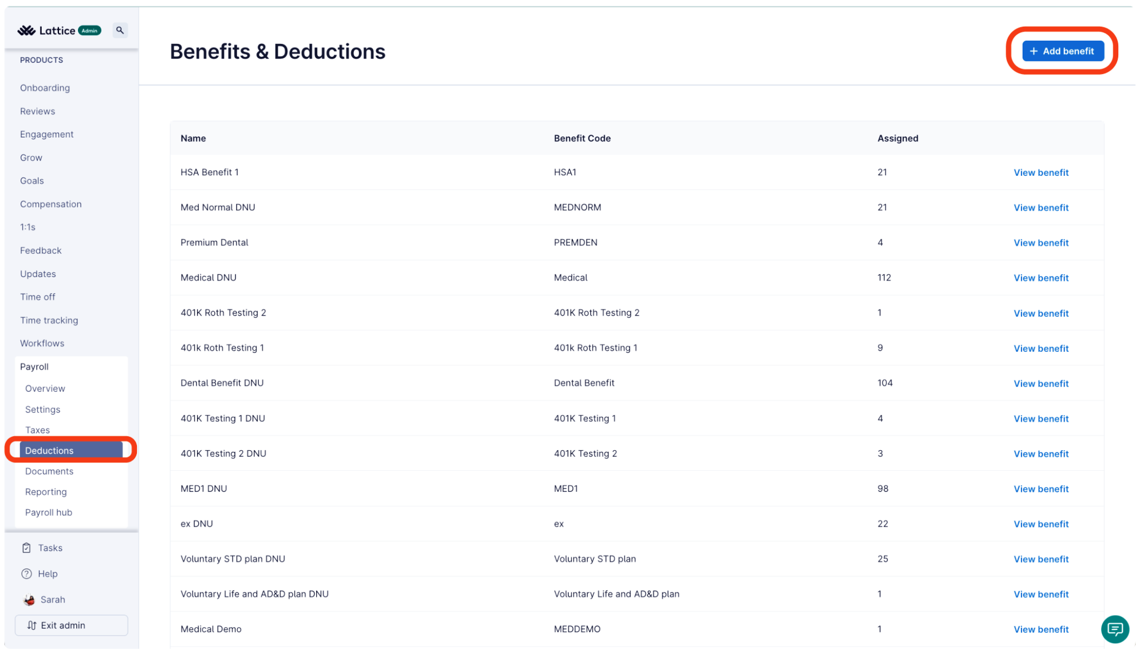

## Frequently Asked Questions

**What are the required fields to create an employee in Employee Navigator?** For an employee to be sent from Lattice to be created Employee Navigator the following fields in Lattice must be populated:

1. Legal first name
2. Legal last name
3. SSN
4. Compensation Data

**Future Dated Benefit:** I have changed a benefit and how it starts in the future. When a benefit is changed to start in the future, Lattice Payroll will display the benefit the day it becomes active in the deductions database.

**Rehires:** When an employee is rehired in Lattice, the employee will sync to EN with their updated start date and any other updated information. Their new start date will be their hire date in EN.

**Employee in Lattice before start date:** If an employee is added to Lattice, before their start date, the employee will be immediately created in EN with the start date as it appears in Lattice.

For example: If I created an employee now in Lattice with a start date tomorrow, the employee will be created in EN today (not tomorrow) but the start date will be tomorrow.

**Can Lattice also integrate with Ease?** Not at this time, as EN is supporting the migration of Ease to the Employee Navigator platform, there is no plan to support net new integrations with the Ease platform. If you have any questions about this please reach out to your EN POC.

**Can I change benefit amounts in Lattice?** If there is a change to a benefit and Employee Navigator, it will automatically sync over. If someone needs to change a benefit and Employee Navigator, it will automatically sync over. However, if someone needs to change someone's benefit for a catch up or special circumstance during payroll, they can edit within Lattice directly and Employee Navigator won't override that until you decide to send a transmission after a deduction audit.